**Ikillweights Brownie Delights Order Form**

Healthy Pleasures. Savage Macros.

Customer Name: ____________________________________

Phone Number: _____________________________________

Email Address: _____________________________________

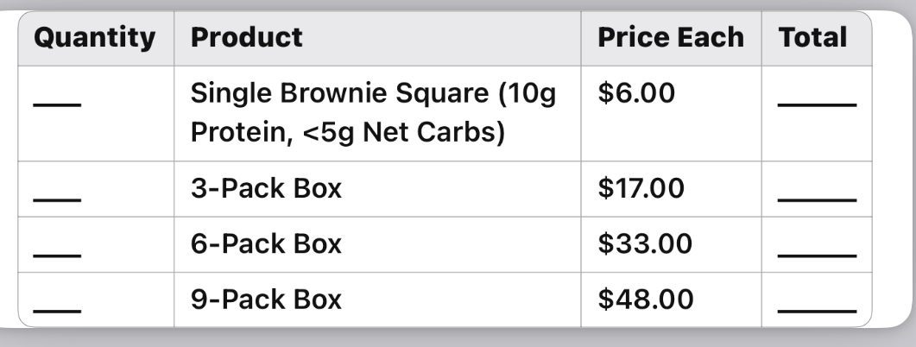

Order Total: $____________________

Preferred Delivery/Pickup Date: _____________________

Delivery Address (if applicable): ___________________________

Payment Method:

* Cash
* Zelle
* Venmo
* Other: ___________________

Signature: ___________________________

Date: ___________________